**IN615008:**

**Switching, Routing and Wireless Essentials**

**Assignment (40%)**

**Student Name: Anthony Legg (#03007276)**

**Due Date/Time:** 5pm, Friday 28 May

## Completed Network

## IP Addressing, VLSM, Port Assignment and Devices

This information is contained in the Excel spreadsheet provided with this document and packet tracer file.

## Assignment Questions 1-7

1. Describe the three layers of the hierarchical network design model and list the advantages it provides.

The three layers are core, distribution, and access.

The primary role at the **core layer** is to forward traffic to its destination as quickly as possible. Core layer devices have high speed ports to forward traffic received from the distribution layer. The core layer is the backbone of a network; will have redundancies in place to provide uninterrupted connectivity in the event of hardware failure and traffic.

The **distribution layer** is the bridge between the access and core layers. This layer handles routing, filtering of traffic, inter-VLAN routing and WAN access. Packets can be forwarded via the best path to the required destination; will be sent to the core layer if needed. Devices at this layer include routers, firewalls, and multilayer switches.

The **access layer** connects end user devices to the local network domain via access points. Any connection to networks outside the local network is handled by the distribution layer. At this layer security measures can be used to limit user access to certain subnets in the network or restrict devices by to access ports. The access layer can also be used to filter MAC addresses and implement load balancing.

**Advantages** of hierarchical network design include:

**Scalability**, 3-tier topology creates a separation of concerns which allows administrators to troubleshoot issues quickly and manage/upgrade the network topology with minimal disruption to end users.

**Performance**, network devices can perform optimally because the topology of the network ensures each device will only receive the traffic required and has capacity to handle.

**Cost effective**, network devices can scale to meet the needs of the end users. Components that make up the infrastructure can be upgraded with minimal disruption and can managed remotely and securely by network administrators.

**Resiliency**, network topology ensures that there is no single point of failure. Any disruption to connectivity is automatically handled by the network hardware, so the end user does not notice any change in service.

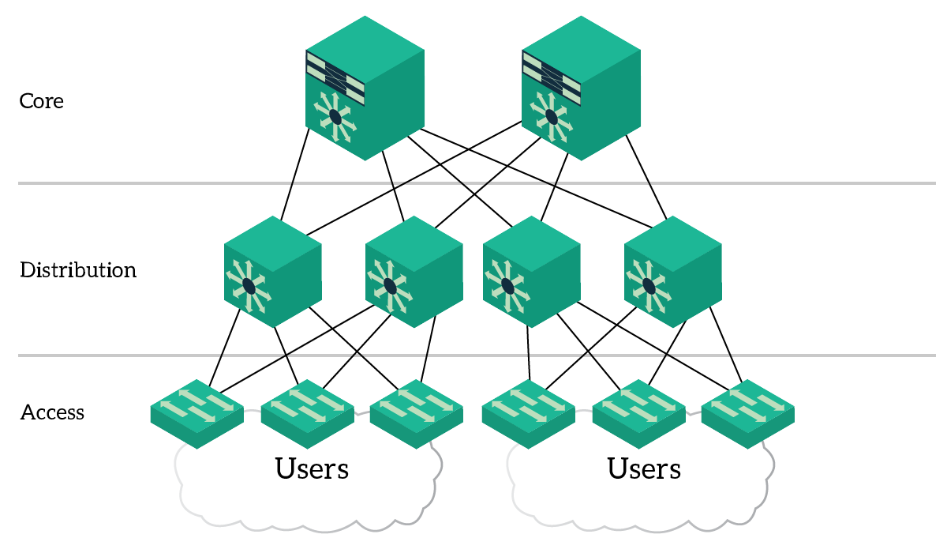

1. Describe how the root bridge, designated ports and root ports would be determined by default.

BPDU’s are exchanged between switches within a domain. BPDU’s contain a root ID and a bridge ID. Bridge ID has a bridge priority, extended system id and the switch mac address. During the root bridge election process, the bridge ID (bid) is used to decide the root bridge, designated, alternate and root ports. The default priority exchanged is 32769 (32768+1 for default VLAN 1). Initially, all switches send BPDUs with a root ID equal to their own bridge ID indicating they are the root bridge. As BPDUs are exchanged/processed a single switch is elected to be the root bridge. Since the ID values are the same for all switches, the extended system id and mac address values are used. The lowest of these combined values will be elected as the root bridge.

Once the root bridge has been elected, the best/root path to the root bridge from across the domain is determined by the sum of all port costs on the path between a switch and root bridge. By default, the path cost is determined by the operation speed of each port on the path. Higher speed ports have the lowest cost. With a path cost established, each non-root bridge can elect a root port which is the port will the lowest cost path to the root bridge.

Designated ports are then elected. These ports have the lowest cost/best path to the root bridge. All ports on the switch elected root bridge become designated ports. Each segment between two switches must have a designated port, if the segment has a root port the opposite port will become a designated port.

Lastly, alternate/blocked ports are elected. These ports administratively block traffic preventing a layer 2 loop forming; will unblock in the event of a failure on a non-blocking segment. A segment must have a designated port, if the opposite port is not a root port, it will be elected an alternate.

1. What is the purpose of the Port-fast command?

The port-fast command is configured on a physical interface that will be connected to end user devices. When a port becomes active, the spanning tree algorithm takes some time going through a listening and learning state to ensure that the connected device will not create a layer 2 loop. This causes a delay in the device becoming active on the network, preventing it from requesting its IP address from a DHCP server. Port-fast can be assigned to the access port to prevent this delay. Should only be used on access ports.

1. What is the of the BPDU-guard configuration?

This is also configured on a physical interface; will shut down the interface in the event a layer 2 switch is connected. This will prevent a layer 2 loop occurring on the network, should someone add a switch to a port that is for end user devices only. Should be used on access ports with port fast.

1. What is the purpose of pre-emption? What does this do?

The standby pre-empt command ensures the Hot Standby Router Protocol (HSRP) router with the highest priority will immediately become the active router. Priority is determined first by the configured priority value, and then by the IP address.

1. What is the difference between stateless and stateful DHCPv6?

Stateless DHCPv6: Routers send RA messages to hosts with IPv6 configuration information for the host to use to join the network (network, subnet, default gateway) along with configuration flags A(utoconfiguration) set to 1, O(ther) set to 1 and the M(anaged) set to 0. These flags inform the host that there is additional configuration information available from a stateless DHCPv6 server. Stateless DHCPv6 has no system to monitor the assignment of IPv6 addresses.

Stateful DHCPv6: RA messages set to hosts provide the default gateway but inform the host that all other configuration information must be provided by the DHCPv6 server that is managing IP assignment. The host must then request configuration from the DHCPv6 server directly. Flags sent in the RA are: A(utoconfiguration) set to 0 and M(anaged) set to 1.

1. Research the function of DR & BDR roles within OSPF. Explain what these are and the default process for DR election.

Routers running OSPF within multiaccess networks transmit link-state advertisements every few seconds to all adjacent routers, which in turn share those with every other router, consuming bandwidth, and CPU capacity. To make this process more efficient, a designated router (DR) and backup designated router (BDR) are elected based on the value of the router ID. Highest value ID is elected as DR, second highest BDR. These routers will receive LSAs from all non-DR/BDR routers. BDR will assume the role of DR if hello messages fail to return a response. This will trigger a new OSPF election process so a new BDR router is created.

## Supporting Evidence (Screenshots)

### Port Aggregation

Provide captured output showing which ports have been aggregated and the type of aggregation (for all port channels).

### HO Spanning Tree Root Bridge

Provide captured output to confirm the root bridge in your topology.

#### HO Distribution Switch 1

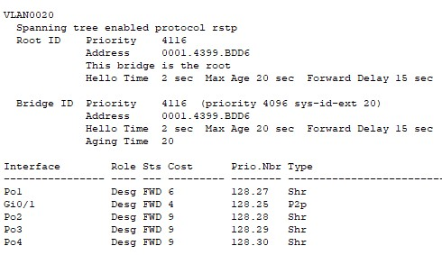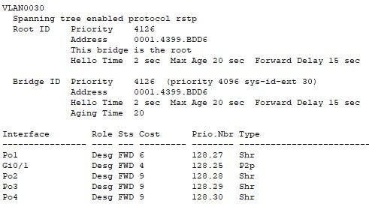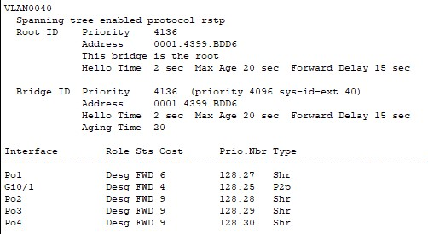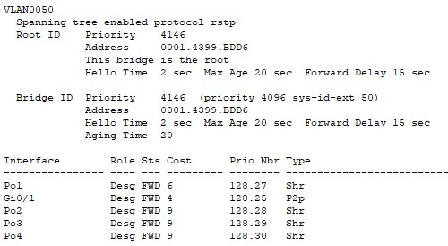

#### HO Distribution Switch 2

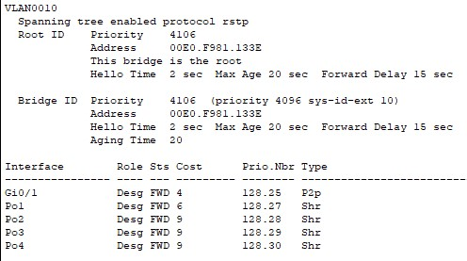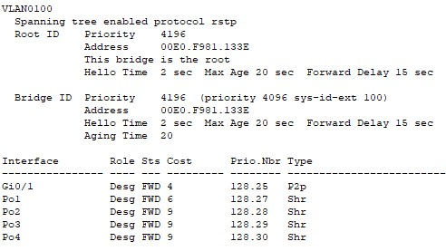

### HO Router Standby Status

### OSPF DR/BDR Relationships – HO Router 1 & 2

### Area 1/WAN OSPF Adjacency

Show output evidence confirming the OSPF adjacency is operational.

#### Dunedin Branch Router 1

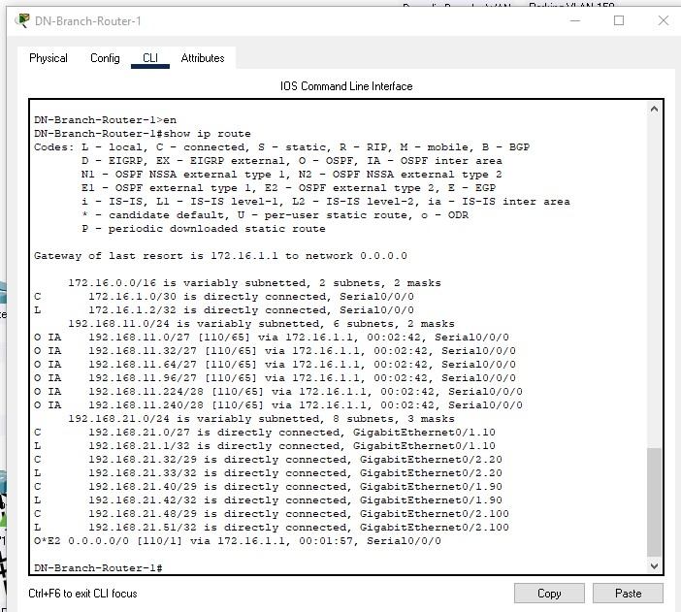

#### HO Router 1

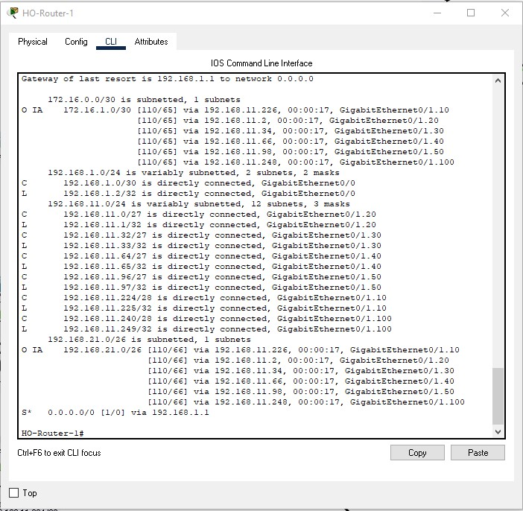

#### HO Router 2

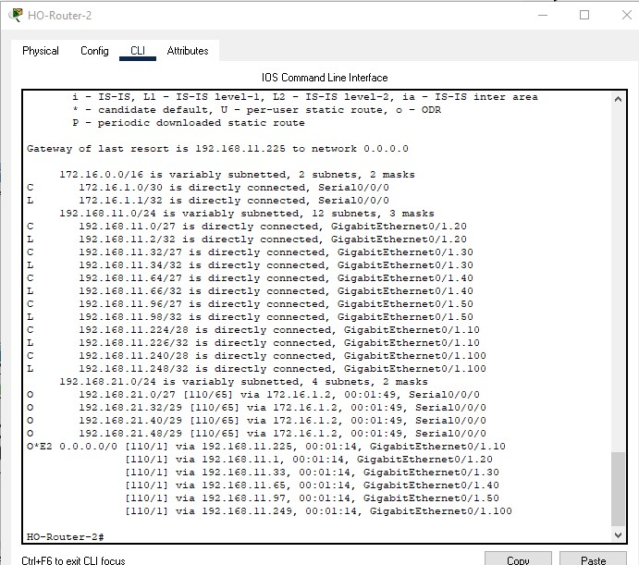

### Site 1/Dunedin Branch Summary Address

Provide evidence output of this being visible on the other HO Router1 (connected to the ISP).

### HO Router 2 DHCP Leases

### Testing

Test results have been provided in the attached excel spreadsheet.